We Love the Northwoods
How to use our “sticker” on Instagram:
- Stickers are gifs without a background that are placed over an image or video in Instagram stories
- To use a “sticker” on an Instagram story:
  - Open Instagram
  - Slide left to create a story
  - Take picture or upload picture to use as story- DO NOT PRESS SEND YET
  - Add sticker
    - 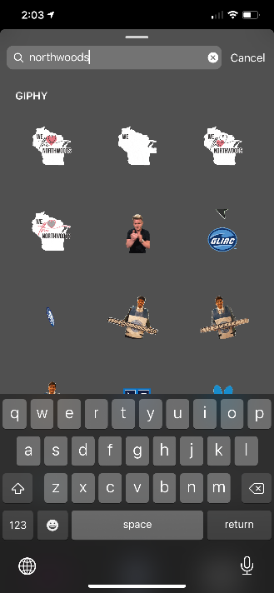
    - Click middle icon in upper left corner
    - In search bar type Northwoods
    - Select sticker you want to use
  - Move sticker
    - Use two fingers to resize and move sticker
  - Finish and post your story.

